Author of entry: Jap-Nanak Makkar, University of Virginia

Date submitted: June 1, 2015

**Genet, Jean (1910-1986)**

SUMMARY

Jean Genet was a poet, novelist, autobiographer and playwright within the Theatre of the Absurd movement. He wrote licentiously on homosexuals and outlaws, and explosively about the dispossessed and powerless, in works such as *Journal du Voleur* (1949, *The Thief’s Journal* [1954]), *Un Chant d’Amour* (1950, *Song of Love*), *Les Nègres, Clownerie* (1957, *The Blacks: A Clown Show* [1960]), and *Les Paravents* (1961, *The Screens* [1962]). His contemporaries recognized him as a unique innovator: Jean-Paul Sartre celebrated Genet’s life in a biography, Jacques Derrida discussed Genet’s construal of the autobiographical mode in *Glas*, and Jean Cocteau described him as the “greatest writer of the modern era.”

MAIN ENTRY

Jean Genet had a life unlike other writers of his stature. Born of an unknown father, he was abandoned by his mother at an early age, and moved around as a ward. His formal schooling ended at age thirteen, when he was granted an apprenticeship in typography, an honourable position from which he ran away. After a few more home and work assignments, each matched by a runaway attempt, Genet was sentenced in 1926 to Mettray, a children’s penitentiary that he would recall favourably in interviews and novels. His term at Mettray ended in 1929, when he volunteered to participate in the army, with which he kept on for years—even joining the colonial troops in Morocco—until deserting in 1936. To avoid capture and imprisonment by the French authorities, Genet traveled abroad, but was nevertheless jailed repeatedly, both abroad and in France upon his return. One of these prison stays allowed him to compose “Le Condamné à Mort” (1942, “The Man Condemned to Death”), a poem that mixed classical meters and homoerotic description. A copy of the poem reached Jean Cocteau, under whose guidance Genet signed a publishing contract for three novels, one poem and five plays.

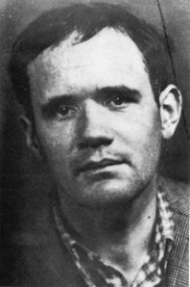

Caption: Identity card photograph of Jean Genet at age 36.  
Copyright: Fonds Jean Genet/Archives IMEC.   
URL: http://a397.idata.over-blog.com/2/48/15/71/Genet-4.jpg

*Early Years: Novels*

Genet’s first major work was the novel *Notre-Dame-des-Fleurs* (1943, *Our Lady of the Flowers* [1949]), circulating at first run in 350 copies. It tells the story of a village-born boy who prostitutes in Montmartre as a drag-queen called Divine. At the time of the story’s telling, Divine is dead from tuberculosis; her most significant love interest, Notre Dame des Fleurs, meets her after committing a murder but before his own execution. The narrator of the story (Genet) is likewise marked by criminality and lasciviousness, announcing that he composes the text in aid of his own masturbatory pleasure while awaiting trial. Each character glories in the abject, criminal, illicit and morbid, as if these qualities were all a means to the transcendent. The paradoxical transvaluation of the abject is a theme presented early but which will be repeated in Genet’s oeuvre. *Miracle de la Rose* (1946, *Miracle of the Rose* [1965]), for example, is set in the historical Fontevrault, a medieval royal abbey used as a prison between 1804 and 1963; Harcamone, set to be executed for killing a warder, possesses the aura of the saint.

The last of Genet’s significant prose pieces is *The Thief’s Journal*, which gives an autobiographical, partly fictionalized, account of Genet’s trip across Europe in the 1930s. Genet passes through Spain, Belgium, Czechoslovakia, Poland and Nazi Germany, recounting his experiences as a thief, prostitute and prisoner. The book, dedicated to Sartre and de Beauvoir, continues to indulge in abjection, while also illustrating the veracity of Sartre’s theories of existential choice. As Genet writes, “Abandoned by my family, I already felt it was natural to aggravate this condition by a preference for boys, and this preference by theft, and theft by crime or a complacent attitude in regard to crime. I thus resolutely rejected a world which had rejected me” (75). Sartre would begin his biography of Genet heavily influenced by *Thief’s Journal*, its will to self-define the individual against the background of social oppression, and its blanket aestheticization of social evils.

Genet’s only complete film, *Un Chant d’Amour* (*Song of Love* [1950]) was finished around the time he parted ways with prose. *Un Chant* is a remarkable early text of gay cinema. It depicts two prisoners in love, as they trade gestures of intimacy and contact despite their separation by a brick wall. Both men are spied upon by a prison guard, and when one of them returns the guard’s gaze—a gesture arising out of the philosophy of Sartre—the guard retaliates by whipping the other male. In black and white and made without dialogue, the film treats common themes for Genet in a superbly fresh cinematic language, distilling his fascination with the abject in pictures. The film influenced the work of Andy Warhol and Derek Jarman.

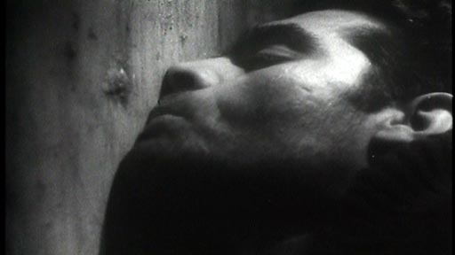

Caption: Prisoner kissing the wall that separates him from his lover.

URL: http://www.prisonmovies.net/un-chant-d’amour-1950-france

*Middle to Late Years: Plays and Politics*

As regards Genet’s oeuvre, Sartre proposed that Genet progressed from the private world of poetry to the public world of the theatre; while his theory may be disputed in finer points, as it was by Edmund White, Sartre fairly describes the authentic shift in Genet to a preoccupation with more political, public content. *Haute Surveillance* (1947, *Deathwatch* [1954]), the first of Genet’s plays to be written carried on with the theme of love among criminals, but *Les Bonnes* (1947, *The Maids* [1954])*,* the first of Genet’s plays to be staged, moved on to representing lower-class envy for high society. In the latter, Claire and Solange, two maids of a Madame, role-play as Madame while she is away, living out their fantasies of disobedience and sadism in her absence. To the multiple levels of performance already in the written text is added the fact that the first staging of *The Maids* featured male actors in the roles of Claire, Solange and Madame.

The plays for which Genet is best remembered are the explosive *The Blacks* and *The Screens*, both dealing with politically oppressed populations.In *The Blacks,* Genet examines the injustices that remain between blacks and whites after centuries of racism and colonialism. In the play, black actors on the main stage enact highly degrading stereotypes for the entertainment of a “Court,” which is elevated on a platform, and which is itself comprised of five black actors wearing white facemasks and performing the role of The Queen, The Valet, The Judge, The Governor and The Missionary. Added to these layers of masquerade and performance is yet another: Genet stipulates in a prefatory note that, “This play, written, I repeat, by a white man, is intended for a white audience, but if, which is unlikely, it is ever performed before a black audience, then a white person, male or female should be invited every evening.” This point is made with insistence and emphasis: should there be no white person in all the audience, masks should be handed out to the black audience. Should the black audience refuse masks, a dummy must be used. Genet’s play depends on infolding and recursive structures: the voyeuristic relation between the Court and the main-stage performers sparks the frame tale, just as the voyeuristic relation between real audience and all performers sparks all the action. The play contains a minimal amount of plot, depending instead on ritual, masquerade and ceremony. Mainstage performers grotesquely celebrate around the coffin of a white woman, until the black actors in white masks descend to the lower stage for their own ritual sacrifice. The play was written between 1957 and 1958, in the aftermath of Ghana’s independence; its first production was in Paris, 1959, directed by Roger Blin.

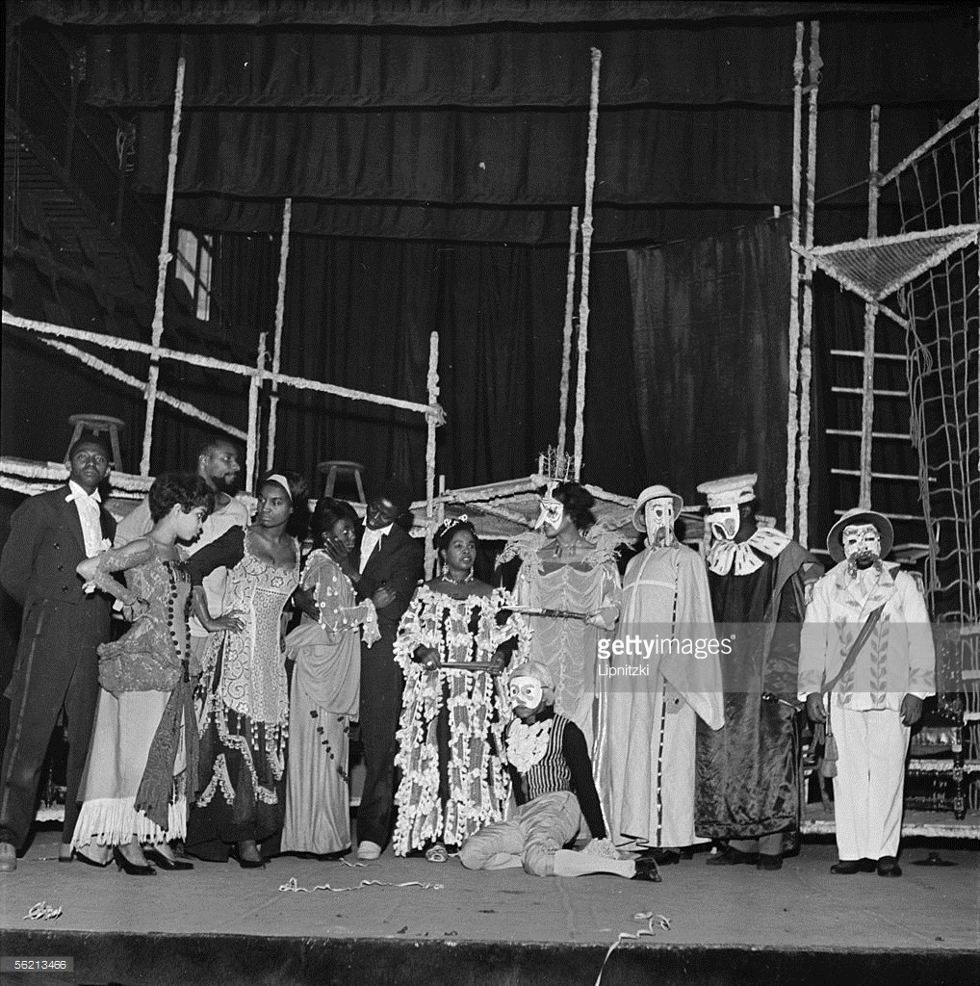

Caption: Cast photo of Roger Blin’s production of *The Blacks.*

Copyright: Lipnitzki/Getty Images

URL: http://www.gettyimages.com.au/detail/news-photo/les-negres-of-jean-genet-production-roger-blin-paris-news-photo/56213466

Genet finished *The Screens*, his last major literary work, in 1961 but it was not performed in France until 1966, that is, until after the end of the Algerian revolution. It served up an excoriating indictment of the failed French colonial mission in Algeria, and, when the play did secure a run at the prestigious Odéon under the direction of Blin, it was predictably met with protests. The text follows Saïd, a poor outcast Arab, his wife Leila, Saïd’s mother, and 100 other characters in 17 scenes. As the play progresses, Saïd and Leila move into a state of profound exclusion, falling into thievery, physical debilitation, and political betrayal. The play positions Saïd in opposition to both the French colonizers, who are depicted as fools, and the Algerian Arabs leading the revolt. Refusing to endorse the socially organized pursuit of justice, even when led by an oppressed people such as the Algerians, Genet suspects that the decaying colonial society will be followed by an equally troubled autonomous society. Within this context, Saïd and his ugly wife, Leila, emerge as saints, committed to an alternative cause: they use their intense experiences of humiliation, exclusion and social abjection to commune with the Absolute. Here, then, Genet gives socio-political substance to themes found in even his first works.

The last phase of Genet’s life, from 1968 to 1986, consisted of little literary activity and significant political action. He advocated for black civil rights, protested among the Black Panthers, rallied with William Burroughs and Alan Ginsberg against the Vietnam War, and socialized with high-ranking officials in the Palestinian Liberation Organization. This period is remarkable for the production of “Quatre heures à Shatila” (1982, “Four Hours in Shatila”), an account of his visit to the Palestinian refugee camp in the aftermath of the Sabra and Shatila massacre, which took place during the 1982 Israeli invasion of Beirut. *Un Captif Amoureaux* (*Prisoner of Love* [1986]), a memoir, expands on his sympathies for Palestinian dispossession. Genet died in a hotel in Paris.

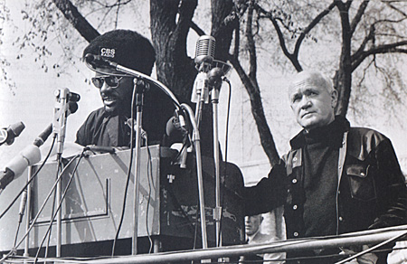

Caption: Jean Genet with Elbert Howard at a Black Panthers meeting. May 1, 1970.

Copyright: David Fonton/Getty Images  
URL: http://www.regietheatrale.com/index/index/thematiques/auteurs/genet/jean-genet-4.html

**List of Works**

**Collected Works**

*Oeuvres complètes*, 4 vols. (1951-68)

*Theaéâtre complet* (2002)

*Treasures of the Night: Collected Poems* (1981)

**Drama**

*Haute Surveillance* (1947); translated *Deathwatch* (1954)

*Les Bonnes* (1947?); translated as *The Maids* (1954)

*Le Balcon* (1956); as *The Balcony* (1957)

*Les Nègres* (1957); as *The Blacks* (1960)

*Les Paravents* (1961); as *The Screens* (1962)

*Elle* (1989)

*Le Bagne* (1994)

**Novels**

*Notre-Dame-des-Fleurs* (1943); as *Our Lady of the Flowers* (1949)

*Miracle de la Rose* (1946); as *Miracle of the Rose* (1965)

*Pompes Funèbres* (1947); translated as *Funeral Rites* (1969)

*Querelle de Brest* (1947); translated as *Querelle of Brest* (1966)

**Poetry**

*Chants Secrets* (1945)

*La Galère* (1947)

*Poèmes* (1948)

**Memoir, Film, Fragments and Interviews**

*Journal du Voleur* (1949); translated as *The Theif’s Journal* (1954)

*Un Captif Amoureux* (1986); translated as *Prisoner of Love* (1986)

*Un Chante d’Amour* (1950, *Song of Love*)

*Lettres à Roger Blin* (1966); as *Letters to Roger Blin: Reflections on the Theatre* (1969)

*Fragments et Autres Textes* (1990); as *Fragments of the Artwork* (2003)

*L’Ennemi Declare: Textes et Entretiens* (1991); as *The Declared Enemy: Texts and Interviews* (2004)

**References and Further Reading**

Esslin, Martin (1961) *Theatre of the Absurd*, New York: Doubleday.

Sartre, Jean-Paul (1952) *Saint-Genet, Comédien et Martyr*, Paris: Gallimard.

White, Edmund (1994) *Genet: A Biography*, New York: Knopf, 1993.

Barber, Stephen (2004) *Jean Genet*, London: Reaktion Books.